Fitting instructions
P 206 WRC

- Dismount the front wings, the rear side windows, the front bumper and the rear bumper.

- Fitting the front wings :
The front skirts must be cut (see the pictures below).
Next, you must place a piece of steel to plug the hole made in the side skirts.
The front wings supports must be half cut. The shelves provided with the wings should be fitted easily. If not, the cutting is insufficient.

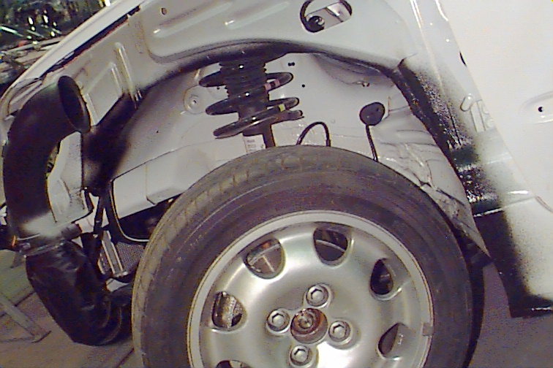

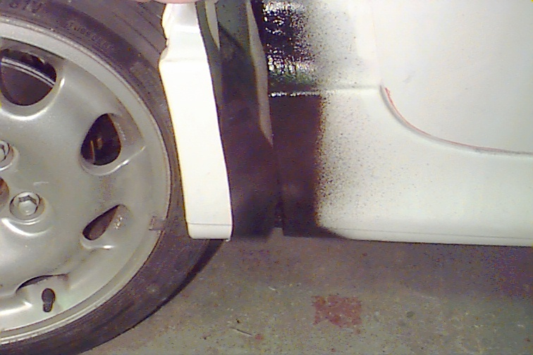

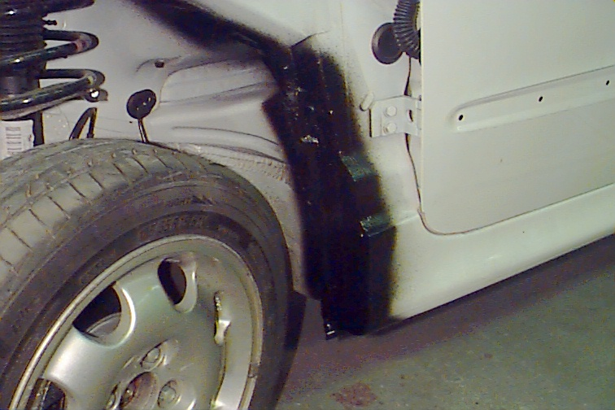

- After cleaning the wings support, fit the front wings with the original fixing point of the car.
The bottoms of the front wings have to be glued with fiber glue on the side skirts. Before that, you must scratch the side skirts and inside the DIMMA wings to ensure a quality gluing.

- Cut the rear wings using the steel wheels arches as guide. The rear shelves must be fitted easily and indicate the sufficiency of the cutting.

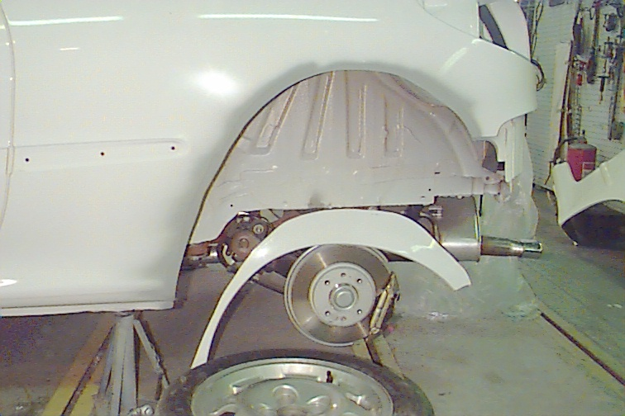

To ensure a quality sticking, it is necessary to scratch deeply the sheet of the rear wings.
You must scratch inside the DIMMA rear wings too, to ensure a good gluing between the original and the DIMMA wings.

- Then stick the rear wings with pliers VISE GRIP and let them during one hour. The best glue is a fiber glue with a slow polymerization. ( maximum one percent accelerator)
- Fit the front and the rear bumper with the original fixing point of the car.

- Sticking of the rear spoiler :

The rear spoiler is fixed on the rear windscreen with a primer and glass glue.
First position the spoiler on the rear windows and with a pen follow the outline of the spoiler on the window.
Then add a special primer for windscreen on the area delimited with the pen
Next tarnish the base of the spoiler to ensure the quality of the sticking.
The sticking must dry during 24 hours.

- Prepare the car before spraying.

A. Pumicing : Tarnish all the parts with glass paper (80)
B. Coat : To ensure the best quality , place with a pistol a fuller on every DIMMA parts
C. Pumicing : With paper 150, and after with 400, purmice all the DIMMA parts.
D. Surfacer : add a surfacer on every parts
E. All the parts and the vehicle must go in oven after spraying at a maximum temperature of 40 °c;

- We suggest a full spraying of the car.

